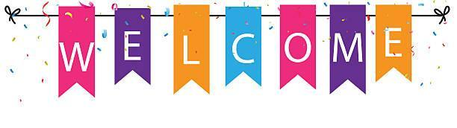

Welcome to P-9!
We are excited for the 2023-2024 school year!
Below is a list of supplies that will be helpful in the success of our classroom.

- 2 Boxes/packs of fat pencils, for example, Ticongeroga brand
- 2 Composition notebooks
- 2 plastic folders
- 1 box of 24 crayons
- 1 box of markers
- A pack of glue sticks
- 2 Tissue boxes
- A pair of over-the-head headphones, labeled. Please do not send headphones that go in the ear
- 2 Rolls of paper towel
- 1 Container of Lysol wipes
- 1 Pack of Expo (dry-erase) markers
- 1 Pack of white copy paper
- 1 Bottle of hand sanitizer
- Backpack and lunch box (unless your child will be eating school lunch).
- 1 Extra set of clothing (please send in more clothing if your child has been sent home in their extra set. Please, label all clothing.)

If your child needs toileting, please send in baby wipes and pull-ups.
*Pull-ups that open on the sides are preferred.

We will be eating snack daily; please send in a snack and water/juice for each day. The school does not provide snack for the children. This is something we do as part of our interpersonal communication curriculum.
.

